|  |  |
| --- | --- |
|  | **2014** |
|  | The Company  Martien Huijsmans |

|  |
| --- |
| **[SmartBear Collaborator** |
| Installation, configuration and usage. |

Inhoud

VIM Commands 1

# Introduction

This document describes installation, configuration and usage of the Smartbear Code Collaborator (a code review tool)

# Installation

Precondition:   
Check version of SmartBear Collaborator server (e.g. 8.2.8201).  
Rationale: Eclipse plugin version must be <= version server  
Note: if you take latest version, plugin will report server version.

Instructions on download: http://eclipse.smartbear.com/  
Followed instruction.

* used update site: <http://eclipse.smartbear.com/8.0>   
  Otherwise you get old plugin.
* Turn of flag “Show only the latest versions of available software”
* Selected plugin version : 8.2.8201.002
  + Optional:   
    Eclipse provides as feedback the screen below.  
    Do not install a version that is not supported (i.e. client version > server version).  
    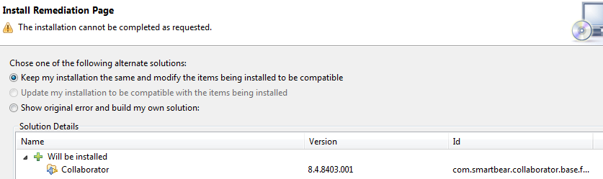

Restarted Eclipse.

# Configuration

Window -> preferences -> Code Collaborator: server URl and Username already set.  
Open: was that because I had used the web based version before?

During a code review, Collaborator may complain about white spaces (which if added, can be considered a change). Collaborator seems to re-use diff-feature sin Eclipse.   
So preference

* search for : white
* under "Compare/Patch" turn on "Ignore white space".
* Restart Eclipse may be needed to make this work.

# Usage

Test cases to explore/compare Web and Eclipse based version.  
Tests involved two persons: me and him.

|  |  |
| --- | --- |
| Test | Observation |
| Him submits a review request via Web | Me: Eclipse lists tasks. Me: no diff in Web. Double check. |
|  | Open: is review before code checkin? |
|  | Can I run the build, etc as part of the code review? |
|  | Email supports the web based flow. No email integration with Eclipse. In Eclipse, you will see incoming review requests in view. Only current, no history like in Web based. |
|  | When submitting an update, I could not add comments. |
|  | After all have approved, I can commit the new code. |
|  | Status of the review request is not as clear as in Web interface. |
| Me creates a review request in Eclipse | Selecting files to review is very basic. You need to navigate to individual files. Changes files (logical choice) not offered. How do I know what to include? |
|  | I could request a review on a file that is not in subversion. File is included. |
|  | When submitting a review request, I also had to include a review template. These were already included. |
|  | Collaborator has a review process (e.g. including an annotation phase). Diagram is visible in web based interface.  After changing in web based interface to |
| Does new plugin impact my current way of working with Eclipse. | Can I still use “SVN repository view” to add a remote repo:? -> YES Can I “checkout as maven project” ? -> yes Can I commit a change? |

Impressions.

* Collaborator uses floating licenses. Impact when using Eclipse plugin is not clear.

# Process

This chapter describes possible processes on how Collaborator can be used.

Implement  
Change

Review  
& Update

Commit  
Change

Create   
branch

Merge  
branch

Implement  
Change

Review  
& Update

Commit  
Change

Delete  
branch

Figure 1 Candidate processes with review

# Limitations

Eclipse crashes when opening in Collaborator a large image for review.